**The White Man’s Burden**

Rudyard Kipling

Take up the White Man's burden--   
Send forth the best ye breed--   
Go bind your sons to exile   
To serve your captives' need;   
To wait in heavy harness,   
On fluttered folk and wild--   
Your new-caught, sullen peoples,   
Half-devil and half-child.   
   
Take up the White Man's burden--   
In patience to abide,   
To veil the threat of terror   
And check the show of pride;   
By open speech and simple,   
An hundred times made plain   
To seek another's profit,   
And work another's gain.   
   
Take up the White Man's burden--   
The savage wars of peace--   
Fill full the mouth of Famine   
And bid the sickness cease;   
And when your goal is nearest   
The end for others sought,   
Watch sloth and heathen Folly   
Bring all your hopes to nought.

1.  **According to Kipling, and in your own words, what was the “White Man’s Burden?”** The White Man’s Burden was to teach and educate the natives.

2. **What words or phrases in the poem show the concept of Social Darwinism?** “By open speech and simple, an hundred times made plain to seek another’s profit and work another’s gain.” This phrase shows that the fittest of society and economics will survive.

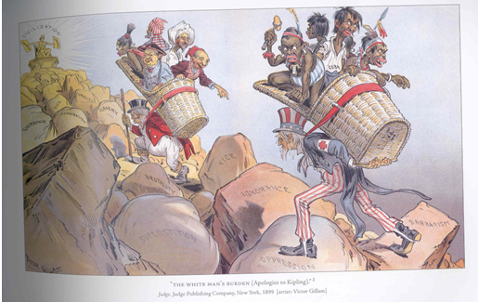

 3. **List four observations about the cartoon.**

I can see that Uncle Sam is carrying a group of natives and a wealthy man carry a group of immigrants. They are going up a terrible some hill, stepping over oppression, ignorance, vice, brutality, and other social problems. They are striving to get to civilization. Uncle Sam and the other man is carrying the uneducated to civilization.

4. **How does this political cartoon show the concept of “White Man’s Burden?”** The cartoon shows Americans saving, educating and civilizing the natives and immigrants.